Chapter 5: Classification

5.1 Classification organises our world

Literacy support worksheet answers (pages 80–81)

Classification history

1 Name two animals that would fit into the following groups:

a Walking

Student responses will vary as there are numerous possibilities.

b Flying

Student responses will vary as there are numerous possibilities.

c Swimming

Student responses will vary as there are numerous possibilities.

2 In which of Aristotle’s groups would a duck belong? Explain why.

The duck would probably be in the ‘fly’ group due to its wings, however, it may also be in the ‘swim’ or ‘walk’ group.

3 In which of Aristotle’s groups would a frog belong? Explain why.

The frog would probably be in the ‘swim’ group due to it hopping as opposed to walking.

4 Both bats and birds would be classified into the ‘flying’ group according to Aristotle. Suggest a reason why these two animals should not be classified in the same group.

Student responses will vary, but could refer to the mouth (teeth vs. beak), body covering (skin vs. feathers), ear shape, eye location, hands and feet.

Carl Linnaeus designed the current system of classification in the 18th century.

5 Why do you think Linnaeus made changes to the classification system?

Linnaeus found the descriptions were too long and decided it needed to be simpler.

WORD DETECTIVE

6 Draw and label

Draw, label and illustrate a classification key that shows how Aristotle classified living things.

Student responses will vary in the appearance and structure of the classification key, but the key should include: the two major groups ‘plants’ and ‘animals’, then by movement (swim, fly, walk). Some other examples of how Aristotle might classify animals, for example, number of legs, body covering, size, etc.,, could be included.

5.2 Living organisms have characteristics in common

Literacy support worksheet answers (pages 82–83)

Living or non-living?

1 All living things share eight key features. Complete the mnemonic (memory trick) below to outline the meaning of each feature. The first one has been done for you.

|  |  |
| --- | --- |
| **M** | Movement: Living things can MOVE by themselves |
| **R** | Reproduce: living things make new individuals that look like themselves |
| **N** | Nutrition: living things require nutrients to survive. |
| **G** | Grow: living things grow as they get older |
| **R** | Respond: living things respond to stimuli around them. |
| **E** | Exchange: living things exchange gases with their environment. |
| **W** | Wastes: living things produce wastes |
| **W** | Water: living things require water to survive |

2 Classify the following as living or non-living.

a a cat

living

b a drop of water

non-living

c an ant

living

d mould

living

e salt

non-living

g bacteria

living

h grass

living

i computer

non-living

3 Light a candle and observe the candle flame. Describe how it carries out each of the eight key features.

|  |  |
| --- | --- |
| **M** | Movement: The flame flickers and moves |
| **R** | • Reproduction: flames reproduce by sparks and matches. |
| **N** | • Nutrition: flames consume wax as they burn. |
| **G** | • Growth: flames can grow as more wax is available. Flames are bigger on bigger candles than on small candles. |
| **R** | • Respond: flames respond to blowing on them, adding more oxygen, or pouring water onto the candle top. |
| **E** | • Exchange: flames consume oxygen gas and produce carbon dioxide gas. These gases are exchanged with each other. |
| **W** | • Waste: candle flames produce carbon dioxide, soot and water vapour as products which they cannot use. |
| **W** | • Water: flames respond badly to water. Flames are extinguished by water. |

4 Based on your responses to the question above, decide whether you think a flame is living or non-living. Explain why.

Even though a flame has many of the features of living things, it is not living. Flames cannot reproduce on their own, and they do not use the wax as nutrition to grow a bigger flame but burn it all into waste

WORD DETECTIVE

6 Word Search

Find the words listed, in the puzzle below.

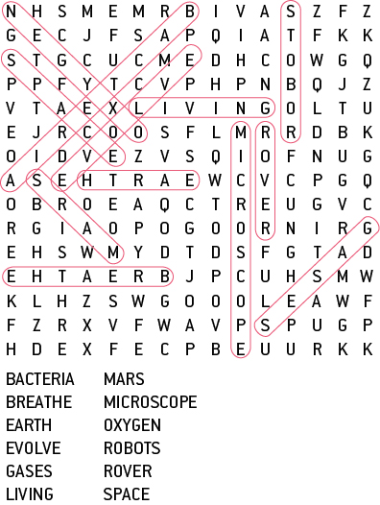

5.3 Classification keys are visual tools

Literacy support worksheet answers (pages 84–85)

Who am I?

1 What is a dichotomous key?

A key is a visual tool used in the classification of organisms.

2 Why do scientists use dichotomous keys?

Scientists use these keys to make simple ‘yes’ and ‘no’ decisions at each branch to assist with classification of organisms.

3 On the next page is a dichotomous key for students in a Science class at *Stickman Secondary College.*

a Use the dichotomous key provided to identify the students in this class at *Stickman Secondary College* on the next page.

A Mina

B Mag

C Pierre

D Hana

E Robert

F John

G Joshua

G Molly

I Cheng

J An

K Ally

L George

b Draw in the missing students.

M Sara: No skirt, no pants, shoes, no hair

N Fatima: Skirt, no shoes, hair no spikes

O Mohammad: No skirt, pants, shoes, hair, spikes

P Fred: No skirt, pants, shoes, hair, no spikes

Q Juan: No skirt, no pants, shoes, hair, spikes

R Isla: Skirt, shoes, no hair

WORD DETECTIVE

4 Word search

Find as many words as possible in the puzzle below.

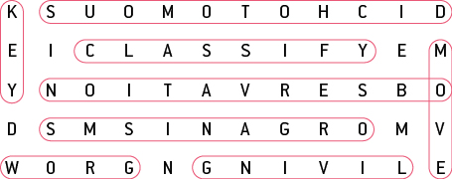

5.4 The classification system continues to change

Literacy support worksheet answers (pages 86–87)

Classification using seven levels

1 Which level of classification (in grey) do you think contains the largest number of organisms?

Kingdom level

2 Which level do you think contains the smallest number of organisms?

Species level

3 Which two species in the table above would be most similar? Explain why.

The human and the snow leopard would be the most closely related because they are the only two species in the same class as each other.

4 Which organism listed in the table above is most different to all the other organisms?

The honey bee is the most different to all other organisms in the table since it is classified in a different phylum to the others.

WORD DETECTIVE

5 Mumbo-jumbo

a Use the marked letters to find the secret word (e.g. olusntoi = solution).

b Unscramble each of the clue words below to find the message.

Message: Scientific names are from the Latin language

Secret word: Genus

5.5 All organisms can be divided into five Kingdoms

Literacy support worksheet answers (pages 88–89)

Kingdoms of life

1 List the five main kingdoms.

Animalia, Plantae, Fungi, Monera, Protista

2 Identify which of the kingdoms has the smallest number of known species.

Kingdom Plantae

3 Identify which of the kingdoms consists of unicellular organisms.

Monera and Protista

4 Explain how the members of the Plantae kingdom differ from all other life forms.

Members of the plant kingdom are autotrophic (meaning they make their own food from sunlight).

5 Which of the kingdoms would be the most successful type of life form on Earth? Explain, giving reasons.

Members of the animal kingdom could be considered the most successful life forms on Earth because they make up the largest group of organisms on Earth – almost 10 to 1 time larger than the next biggest kingdom (Fungi).

WORD DETECTIVE

6 Match a Word

Draw a line from the word to the description.

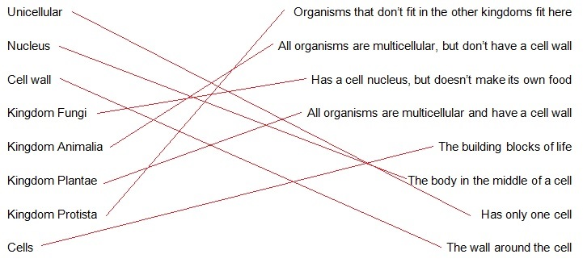

5.6 Animals that have no skeleton are called invertebrates

Literacy support worksheet answers (pages 90–91)

Butterfly or moth?

1 A moth makes a silken cocoon whereas a butterfly makes a hard smooth chrysalis. What is an exoskeleton?

An exoskeleton is an external skeleton.

2 Both butterflies and moths are classified as insects. How can you tell the difference between insects and spiders?

Student responses will vary, but could include number of legs as the main distinguishing feature.

3 Use the information to draw the life cycle of a butterfly or a moth.

The life cycle (according to the information) is caterpillar larva, pupa, moth (cocoon) or butterfly (chrysalis).

4 Use the characteristics above to draw a butterfly and a moth. Label the similarities and differences between them.

Similarities: number of legs, exoskeleton, wings.

Differences: antenna shape, wing structure, posture, forelegs, active times, colouration, pupa covering.

WORD DETECTIVE

5 Secret message

Use words from the student book to work out the secret message below:

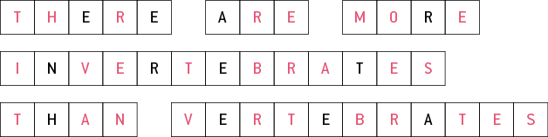

5.7 Vertebrates can be organised into five Classes

Literacy support worksheet answers (pages 92–93)

Classifying vertebrates

1 Using your student book, list the five classes of vertebrates.

Class Mammailia, Class Aves, Class Reptilia, Class Amphibia, Class Pisces

2 Decide whether each of the following statements is true or false.

a A kingdom is a bigger group than a phylum.

True

b All animals in Class Aves lay eggs.

True

c A cat is a endotherm.

False

d Turtles belong to Class Amphibia.

False

e A frog is an example of a reptile.

False

3 Describe what determines whether an animal is a vertebrate or an invertebrate.

Vertebrates have a spine or a backbone. Invertebrates do not.

4 What are the tree subgroups of Class Mammalia? What is the feature used to separate these subgroups?

Monotremes, marsupials, placentals. The main feature used to separate mammals into subgroups is how their young develop.

5 Below is a table of vertebrates. Highlight similar characteristics in the same colour.

Phylum Chordata (vertebrates)

|  |  |  |  |  |  |
| --- | --- | --- | --- | --- | --- |
| **Class** | **Body cover** | **Reproduction** | **Breathing** | **Body temperature** | **Common name** |
| Aves | Feathers | Eggs | Lungs | Endotherm | Birds |
| Pisces | Moist scales | Eggs | Gills | Ectotherm | Fish |
| Mammalia | Skin with hair or fur | Mostly live young | Lungs | Endotherm | Mammals |
| Reptilia | Moist scales | Eggs | Lungs | Ectotherm | Reptiles |
| Amphibia | Moist skin | Eggs | Gills and lungs | Ectotherm | Amphibians |

WORD DETECTIVE

7 True or false?

Read the statements below and circle whether each one is T for True or F for False.

a Invertebrates have a backbone

F

b Dolphins are mammals

T

c Birds are warm blooded

T

d Fish are in the family Pieces

F

5.8 Plants can be classified according to their characteristics

Literacy support worksheet answers (pages 94–95)

Plants from the dinosaur age

1 The bark of the Wollemi pine, below was once described as looking like it was covered in ‘coco pops’. Can you use more scientific terms to describe what it looks like?

Student responses will vary, but an example could be rough and bumpy, a rough vascular cambrian, or a rough external covering or a rough outer layer.

2 Wollemi pine trees have large seeds that look like wings. How could these seeds be spread into new areas?

The ‘wings’ would allow the seeds to glide with the wind to spread into different areas.

3 a How might the Brachiosaurus (the dinosaur pictured) help with spreading the Wollemi pine seeds? (Look at what the Brachiosaurus is doing.)

The Brachiosaurus would consume the seeds contained in the cone and then defecate (evacuate its bowels) in a different location.

b What might the Brachiosaurus provide to help the Wollemi pine seeds grow? (Think about what we add to plants to give them nutrients to help them grow).

The Brachiosaurus faeces (manure) would provide fertiliser for the seeds.

4 Why is it important for seeds to move away from the parent tree before growing?

The parent tree is much larger than a seed so there needs to be space, water and nutrition for the new seed to grow.

WORD DETECTIVE

5 Crossword

Use the clues below to complete the crossword.

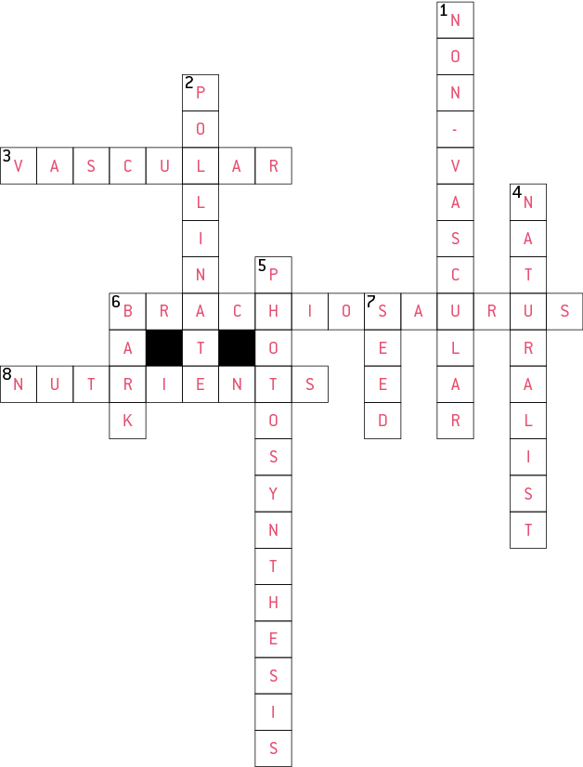

5.9 Science as a human endeavour: The first Australian scientists classified their environment

Literacy support worksheet answers (pages 96–97)

Aboriginal medicines

1 When testing a plant for the first time, early scientists did not put it in their mouth. Instead they would rub a small amount on their skin. Suggest one reason why they tested plants in this way.

If the plant was poisonous and it was put in the early scientists’ mouth first, the poison would be quickly absorbed into the bloodstream and could cause illness or death. If a reaction occurs on the skin, the poison can be washed off and the reaction would hopefully be localised.

2 Why would scientists prefer to use the scientific names for the plants rather than their traditional names?

The scientific names are a universal language so it doesn’t matter which country a scientist is from since they can identify the scientific name of a plant rather than trying to work out the traditional names, which can vary from place to place.

WORD DETECTIVE

3 Fill in the gaps

Read the information below and fill in the gaps using the words below.

Australia’s arid zone receives less than 250 millilitres of rainfall per year. The traditional owners of the land, the Anangu people knew where to find food to survive. They also knew which areas were the best for hunting and gathering. The Anangu people classified their environment in their own language to help them locate the precious food.